William Johnson
Mohammed Abdulal
11/3/11
Abstract
Savin Hill Cove Dredging

With our capstone project Mohammed Abdulal and I hope to turn the area of Savin Hill Cove in to a healthy ecosystem with abundant biodiversity. Another option we hope to explore is the option of turning it to a brown field. One major issue with the area currently is the amount and quality of the sediment. Some sources of the sediment are The Neponset River as well as from the heating and cooling system of the university. This is important to consider because it creates a costly expense to the university in the form of dredging. When talking to Chris Sweeney, UMB Director of Marine Operations, we learned that this process cost 22$ per yard and cost millions in total. The most resent dredging being 5-6 years ago. And historically needs to be performed once every 10 years. We hope to determine an alternative or a more efficient and economical way for dredging so that all possible stakeholders are benefit.
As stated in Caitlyn Mello and Gwendolyn Richard report form last semester much of this sediment is from The Neponset River. And we have learned from reading their report that
“that The Neponset River Watershed Association is also proposing the removal of the Tileston & Hollingsworth (T&H) Dam and the Baker Dam to improve water quality and allow migration for marine species. “

In this portion of there report they state that it is unknown weather or not this will increase or decrease sediment in the cove. This is something we plan to investigate and elaborate on further in our report.
We believe that turning the area in to a brown field will be beneficial because it will allow for more funding. However one draw back from this would be the fact that if the sediment would be more expensive to dredge. When talking to Chris Sweeney we learned that much of the cost to dredge the area is from environmental permits and studies. Also important to understand is if the sediment considered poor enough quality it would have to be treaded at 44$ instead of 22$ a cubic yard before being dumped 6 miles off shore.
Also with the help of Prof. Frankic we found the http://www.mwra.state.ma.us/harbor/enquad/pdf/2006-01.pdf website to be very helpful. In this report The Savin Hill Cove is referred to as site “T04”. And when reading it we found that the site was rated very poorly in many of the tests. One that caught my eye was the mean Total Organic Carbon in the water was significantly higher than all the other sites on the report.
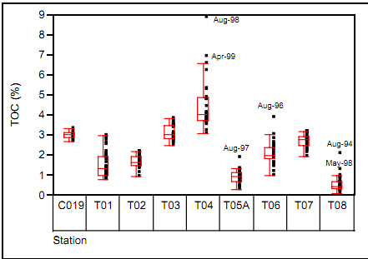
this is something that we hope to further research the effects of and options for improving.

